DATE: 21.06.2019
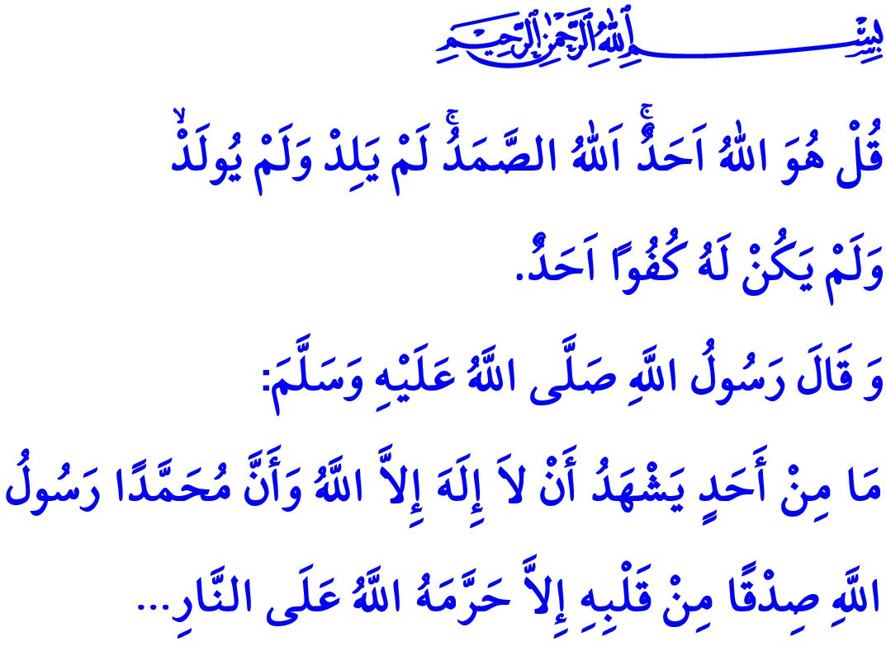
FAITH IN ALLAH
Dear Muslims!
The Almighty Allah (swt) states in the Surah al-Ikhlas that I have quoted at the beginning of the khutbah, “Say: He is Allah Who is One and Only; the Sustainer needed by all; He neither begets nor is born; and there is none equivalent or comparable to Him.”
In the hadith I have quoted, the Prophet Muhammad (saw) states, “Whoever sincerely testifies that none has the right to be worshipped but Allah and Muhammad is His messenger, Allah will save him from the Hellfire.”
Honorable Believers!
Allah the Almighty (swt) is the Lord of the worlds. All kinds of praise and thanks, power and magnificence, supremacy and superiority pertain to Him. Whatever exists in the heavens and on earth is owned by Him. Allah the Exalted (swt) has an absolute power and endless wisdom. He is the one who creates death and life, bestows property and authority, and glorifies or abases those whom He desires. He is the one Who creates and continues to create. He is the one Who lets people live, gives livelihood to them, and feeds and protects them. He is the only one Who dominates in, executes and manages every field and moment of life. Thus, it is stated in the Holy Qur’an, “Of Him seeks (its need) every creature in the heavens and on earth: Every day in (new) splendor doth He (shine)!”
Dear Believers!
Faith in Allah is the first condition of being honored with Islam. Believing in Allah’s (swt) existence, oneness, uniqueness, and having no equivalence and partner, that is to say, adopting tawhid is the basis of principles of faith. The greatest right Allah (swt), Who created us from nothing and lets us live with His endless blessings, has over us is us having faith in Him.
Honorable Muslims!
Faith in Allah (swt) requires following the Prophet assigned by Him, living by the Holy Qur’an sent down by Him, and showing submission to His commands and rulings. Muslims do not consider faith in Allah (swt) as uttering some words only. On the contrary, faith in Allah (swt) makes it obligatory to know Allah (swt) by means of both the verses of the Holy Qur’an and the hadiths of the Prophet Muhammad (saw) and to live a life in line with this faith. Having faith in Allah (swt) adds meaning to the lives of Muslims, guides their ideas and decisions, and affects all their relations with all living and non-living beings. Therefore, faith which is uttered by Muslims and takes root in their hearts is, in fact, the assurance of benevolence on earth.
Dear Believers!
Those who believe in Allah (swt) observe the consent of the Almighty Allah (swt) in everything they do. They protect the rights of their family, relatives, neighbors, and employees. They fulfill every job undertaken with the consciousness of trust.
Those who believe in Allah (swt) know that even the smallest benevolence will be rewarded and even the smallest evil will be punished. They do not attach more importance to the world than the Hereafter, and they live a life for which they can account.
Those who believe in Allah (swt) cannot be rude and oppressive. On the contrary, they value consultation in all their endeavors. They adopt mercy and compassion as principle.
Muslims who believe in Allah (swt) are tightly bound to their homeland, fellow citizens, religion, and values. They may sacrifice their property and even their life, but they do not turn away from their sacred values.
Honorable Muslims!
Faith in Allah (swt) is a reliable guide to lead us to the true path in the world, and take us to heaven in the Hereafter. Our faith in Allah the Exalted (swt) is our most precious treasure as us being His servants. Spending a life with faith in Allah, accompanying our deeds with our faith, uttering the words of faith in our last breath, and leaving faithful generations are all our desire.
I would like to conclude with the following words of the Prophet Ibrahim (as) as stated in the Holy Qur’an, “He is the One Who created me, and He alone guides me. He is the One Who provides me with food and drink. And He alone heals me when I am sick. And He is the One Who will cause me to die, and then bring me back to life. And He is the One Who, I hope, will forgive my flaws on the Day of Judgement.”

Ikhlas, 112/1-4.
Bukhari, 'Ilm, 49.
Rahman, 55/29.
Shu'ara, 26/78-82. General Directorate of Religious Services

